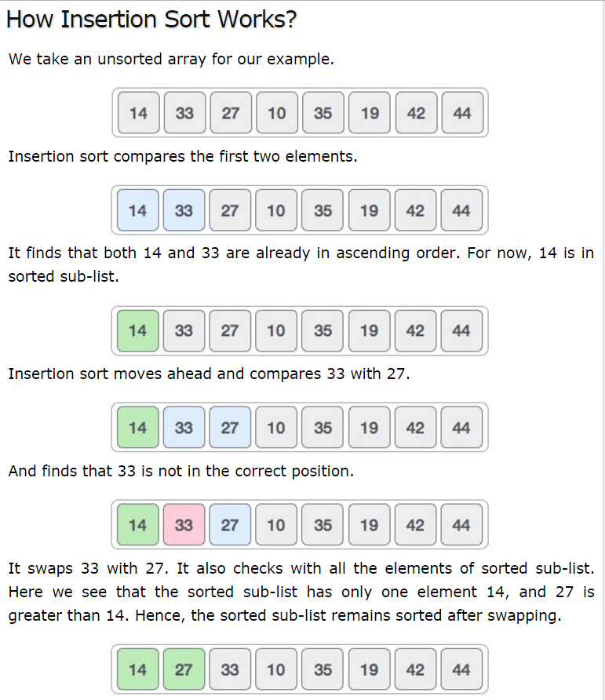

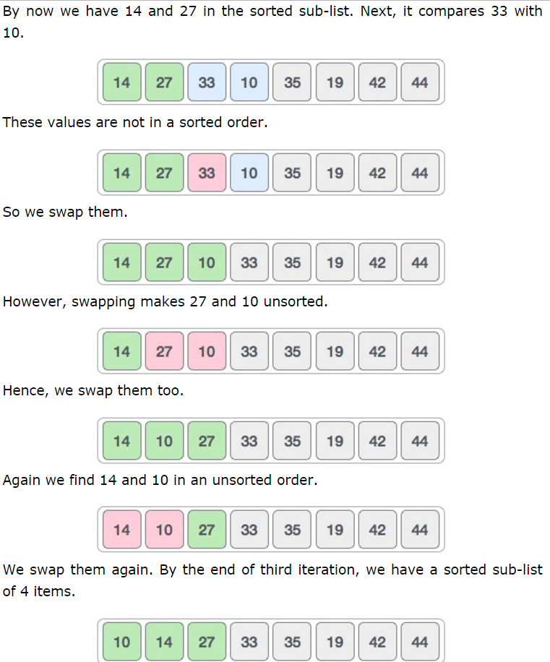

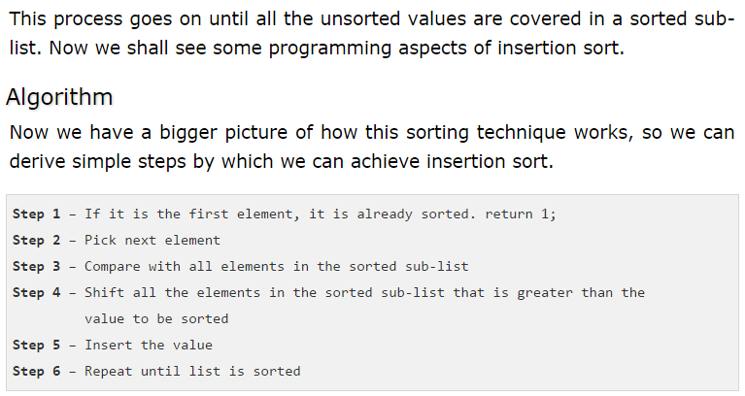

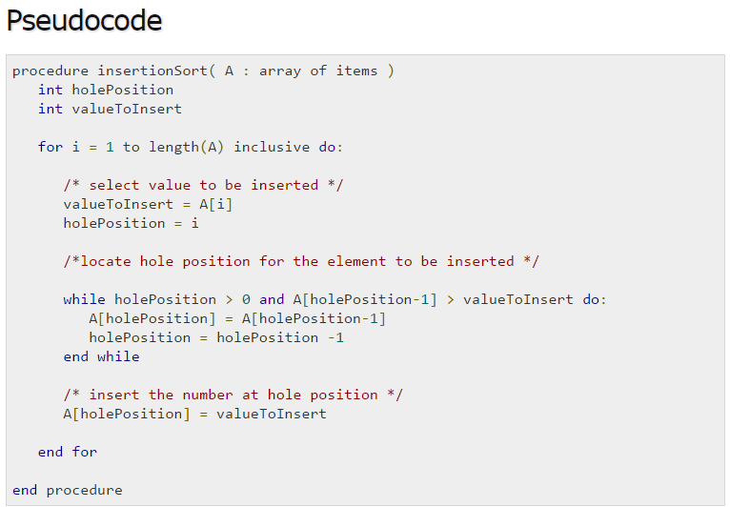

#include <stdio.h>

#include <stdbool.h>

#define MAX 7

int intArray[MAX] = {4,6,3,2,1,9,7};

void printline(int count) {

int i;

for(i = 0;i <count-1;i++) {

printf("=");

}

printf("=\n");

}

void display() {

int i;

printf("[");

// navigate through all items

for(i = 0;i<MAX;i++) {

printf("%d ",intArray[i]);

}

printf("]\n");

}

void insertionSort() {

int valueToInsert;

int holePosition;

int i;

// loop through all numbers

for(i = 1; i < MAX; i++) {

// select a value to be inserted.

valueToInsert = intArray[i];

// select the hole position where number is to be inserted

holePosition = i;

// check if previous no. is larger than value to be inserted

while (holePosition > 0 && intArray[holePosition-1] > valueToInsert) {

intArray[holePosition] = intArray[holePosition-1];

holePosition--;

printf(" item moved : %d\n" , intArray[holePosition]);

}

if(holePosition != i) {

printf(" item inserted : %d, at position : %d\n" , valueToInsert,holePosition);

// insert the number at hole position

intArray[holePosition] = valueToInsert;

}

printf("Iteration %d#:",i);

display();

}

}

main() {

printf("Input Array: ");

display();

printline(50);

insertionSort();

printf("Output Array: ");

display();

printline(50);

}

Output

Input Array: [4 6 3 2 1 9 7 ]

==================================================

Iteration 1#:[4 6 3 2 1 9 7 ]

item moved : 6

item moved : 4

item inserted : 3, at position : 0

Iteration 2#:[3 4 6 2 1 9 7 ]

item moved : 6

item moved : 4

item moved : 3

item inserted : 2, at position : 0

Iteration 3#:[2 3 4 6 1 9 7 ]

item moved : 6

item moved : 4

item moved : 3

item moved : 2

item inserted : 1, at position : 0

Iteration 4#:[1 2 3 4 6 9 7 ]

Iteration 5#:[1 2 3 4 6 9 7 ]

item moved : 9

item inserted : 7, at position : 5

Iteration 6#:[1 2 3 4 6 7 9 ]

Output Array: [1 2 3 4 6 7 9 ]